A new LASSO-BiLSTM-based ensemble learning approach for exchange rate forecasting

Siyuan Liu ª, Qiqian Huang ª, Yunjie Wei ^{b,c,}
ª Beijing 101 middle school
^{b} Academy of Mathematics and Systems Science, Chinese Academy of Sciences, Beijing, 100190, China
^{c} Center for Forecasting Science, Chinese Academy of Sciences, Beijing 100190, China

Abstract: Foreign Exchange Rate affects many countries’ economic status and development. Therefore, it is essential to find the factors affecting the exchange rate price and make reasonable predictions. This paper proposes the novel LASSO-BiLSTM-based ensemble learning method by integrating LASSO and BiLSTM to predict the USD/CNY exchange rate. This paper, 29 market-level variables and macroeconomic variables are selected to predict the monthly United States Dollar to Chinese Yuan (USD/CNY) exchange rate. The LASSO-BiLSTM-based ensemble learning approach contains two parts. First, the LASSO method is utilized to select the six most correlated variables with the exchange rate for future prediction; Second, the BiLSTM is employed to forecast exchange with the six chosen variables. Moreover, to test the effectiveness of BiLSTM, a comparison with four deep learning algorithms, extreme learning machine (ELM), kernel extreme learning machine (KELM), long short-term memory (LSTM), and support vector regression (SVR), are conducted. Root mean squared error (RMSE) and mean absolute error (MAE) are employed for analysis to demonstrate the accuracy of the prediction. This paper found that the proposed LASSO-BiLSTM-based ensemble learning method provides the best predictive result overall.

Keywords:exchange rate forecasting, BiLSTM, LASSO, macroeconomic factors, market-based variables

- Introduction
Foreign exchange rates are always characterized by high volatility and uncertainty since it is influenced by numerous unstable factors, such as economic factors and geopolitical events. However, forecasting the foreign exchange rates is essential for the government as it relates to the country’s financial security and may be used to improve the accuracy and foresight of policy making. Moreover, for enterprises and individuals, accurate foreign exchange rates may help them to hedge risks and gain considerable investment income. Thus, various models are adopted to precisely capture the complexity and nonlinearity of the foreign exchange rates. This research aims to predict the exchange rate of USD/CNY by employing new combinations of variables and using different neural network models, improving the original methodology.
These methods can be divided into three categories: 1) econometric and statistic methods, including ARIMA, GARCH, VAR, etc. Econometric and statistical methods always have the stationarity assumption and perform better with stationary data. However, the predictions would be far less than ideal with the nonstationary data. 2) artificial intelligence model, including ANN, SVR, NN, etc. Artificial intelligence models overcome the shortages of econometric and statistic methods, but also have parameters optimal and overfitting problems. 3) Hybrid approach, which can combine parametric and nonparametric techniques. Ince & Trafalis divided the prediction process into two stages, using ARIMA to determine the correct input in the first stage, and combining ANN and SVR to forecast the exchange rate in the second stage (Ince & Trafailis, 2006). Henríquez & Kristjanpoller (2019) firstly used ICA to extract the noise of time series and then used NN in forecasting. Other hybrid models such as ANN-GJR (Baffour et al., 2019), and GRU-LSTM (Islam & Hossain, 2020) were used in recent years. Whereas existing literature mainly adopted a data-driven framework. The long-term result may not be captured accurately without comprehensively considering the influence of correlated variables.
Traditionally, macroeconomic and market-level variables are used to forecast the exchange rate. Since macroeconomic variables and the exchange rate are strongly and directly correlated, the predictions were made in various countries. Nor & Masron (2020) analyzed the situation in Somalia and illustrated that shocks and macroeconomic factors lead the high volatility. Kim & Park concluded that specific macroeconomic variables affect short-term and long-term fluctuations of the exchange rate in the US, respectively. Moreover, the relationships between macroeconomic variables and the exchange rate vary in different countries.
Market-level variables may be divided into different categories. For instance, for the commodity market, the cross-correlations between the exchange rate and commodity prices were analyzed (Cashin et al., 2004) (Lu et al., 2017). Some pieces of literature may focus on specific commodities and takes the financial market into account, studying correlations across energy, gold, the stock market, and the exchange rate (Sujit & Kumar, 2011) (Jain & Biswal, 2016) (Singhal et al., 2019). Others may use google trends to predict the exchange rates since it represents public opinions to a certain degree and may be more accurate in predicting the actual directions of change in the nominal exchange rate (Bulut, 2018).
However, existing literature mainly analyzed the relationship between macroeconomic and market-level variables, and few use both to predict the exchange rate. Moreover, among these variables, some may have the highest relevance to the exchange rate (Wei et al., 2018). Thus, filtering out the most necessary variables and excluding variables with weak relevance may reduce noise, providing a more accurate result.
Based on the literature, we proposed a novel LASSO-BiLSTM-based ensemble learning approach for exchange rate forecasting. First, the LASSO is used to filter the macroeconomic variables and market-based variables; Second, the BiLSTM is utilized to forecast the exchange rate with the chosen variables.
The major contributions in this paper are as follows. First, compared with the previous study, it is the first time that the market-based variables and macroeconomic variables have been selected to predict the exchange rate of USD/CNY and this new method may take market sentiment, uncertainty, public opinions, and other explicit relationships between macroeconomic variables and exchange rate into account. Second, LASSO filters out six variables with the highest relevance before the models are utilized since excessive variables may lead to overfitting. Third, to the best of our knowledge, BiLSTM is used to predict the exchange rate for the first time. And the empirical study shows that the proposed LASSO-BiLSTM approach can outperform the benchmarks.
The rest of this study is organized as follows. Section 2 introduces the related models, including LASSO, SVR, ELM, LSTM, BiLSTM, and KELM. Section 3 proposes 29 initially chosen variables in four different categories, six selected variables with the most significant relevance, and the adopted evaluation criteria. Finally, the performances of five neural network models and the other five LASSO-combining models are compared horizontally in Section 4.
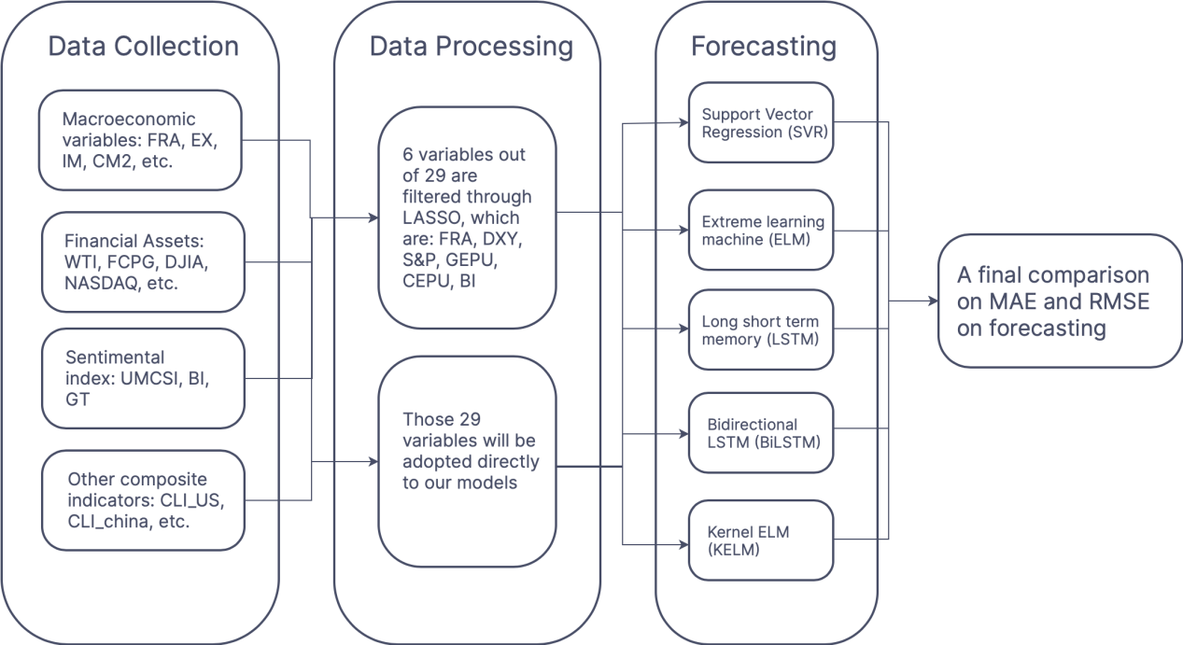

Figure 1. A LASSO-BiLSTM-based ensemble learning approach
- Methodology
In this research, we employed several novel approaches for dollar against CNY forecasting. The least absolute shrinkage and selection operator (LASSO) method is used to select several optimal variables out of 29. Bidirectional long short-term memory (BiLSTM) model, extreme learning machine (ELM), kernel extreme learning machine (KELM), long short-term memory (LSTM), and support vector regression (SVR) models will be used in forecasting dollar against CNY, and its accuracy will be compared amongst these models.

2.1 Least absolute shrinkage and selection operator
The LASSO is a powerful method for variable selection and constructing regression. Tibshirani (1996) invented this method, which is used to enhance the testing accuracy of the model used afterward. The basic idea of LASSO is that it adds a penalty to the model’s residual sum of squares (RSS) (Tibshirani, 1996). It will accelerate the penalty if the RSS exceeds the penalty term; therefore, a regularization process will be applied to shrink some of its coefficients to zero so the penalty will not be too high (Tibshirani, 1997). Thus, only several features are left, and feature selection is achieved.
The LASSO method can bring us several advantages. First, the LASSO method can increase the interpretability of the regression model due to the shrinkage of several redundant or least correlated variables. Researchers can then interpret which explanatory variable has the more significant effect on the response variable, eliminating irrelevant variables that are not correlated. Second, this process reduces overfitting. Overfitting usually occurs when the training model has too many explanatory variables. Although the model will work well in training, it does not work well in testing data. The LASSO feature selection method reduces overfitting, where a more accurate prediction of testing data will be achieved. Last, a trade-off between bias and variance will be found. This is because when the penalty term increases, bias increases and variance decreases, thus making the model less complex and reaching a balance between bias and variance.
In a linear model, we assume the formula will be
$$Y=Xβ+ε$$
with response variable Y and explanatory variable X. X can also be defined as an X_{n*k} matrix and Y can be defined as a Y_{n*1} matrix in vector form.
The LASSO minimizes the RSS with an upper bound to the sum of the absolute values of the model parameters. The upper bound is denoted as t.
$$minimize\sum_{i=1}^{n}{{\left(y_{i}−\sum_{j}{x_{ij}β_{j}}\right)}^{2} subject to \sum_{j=1}^{k}{\left|β_{j}\right|<t}}$$
Which also means in vector form, the optimization will be
$$minimize \left(\frac{{\left|Y−Xβ\right|}_{2}^{2}}{n}\right) subject to \sum_{j=1}^{k}{\left|β_{j}\right|<t}$$
A penalty term λ is added before the sum of model parameter’s absolute value. The larger the penalty term, the more shrinkage the model will be. Therefore, the parameter estimation will be
$$\hat{β}\left(λ\right)=\underset{β}{argmin}\left(\frac{{\left|Y−Xβ\right|}_{2}^{2}}{n}+λ\sum_{j=1}^{k}{\left|β_{j}\right|}\right)$$
For some values of j, β_{j}(λ) = 0. In this circumstance, these features with coefficient = 0 will be excluded from the model. Note that the penalty value is changed by researchers. Therefore, the LASSO method of feature selection is a useful method for feature selection in machine learning.

2.2 Long short-term memory and bidirectional long short-term memory
The long short-term memory (LSTM) and bidirectional long short-term memory (BiLSTM) are modeling techniques that can predict a variable based on existing variables. BiLSTM is a bidirectional LSTM approach that can detect both positive and negative cues. Both methods are instrumental, where many explanatory variables need to be explained.
Hochreiter and Schmidhuber (1997) invented the LSTM approach. The key idea behind the LSTM approach is to regulate the cell states by using three gates, the input, forget, and output gates. The forget gate determines whether the information should be kept or forgotten. The input gate determines how much information appears in the input values. The output gate controls information output from the cell state to the hidden state (Hochreiter & Schmidhuber, 1997). Figure 2 demonstrates the architecture of LSTM.

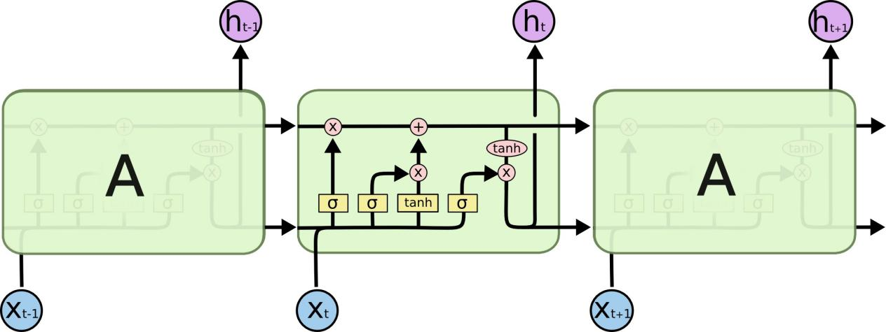
Figure 2. Graphical representation of LSTM

LSTM replaces the nodes of the recurring neural network (RNN) model with special cells, which solves RNN’s vanishing gradient problem (Aslan et al., 2021). The LSTM calculated the hidden state h_{t}, for gates, transformation, and state update, at time t (Sherstinsky, 2020). The initial data sequence inputted into the LSTM is represented as x₁, x₂, …, x_{n}. The LSTM model can be described as follows:
Gates:
$$f_{t}=\text{sigmoid}\left(W_{f}∙\left[h_{t−1},x_{t}\right]+b_{f}\right)$$
$$i_{t}=\text{sigmoid}\left(W_{i}∙\left[h_{t−1},x_{t}\right]+b_{i}\right)$$
$$o_{t}=\text{sigmoid}\left(W_{o}∙\left[h_{t−1},x_{t}\right]+b_{o}\right)$$
Transformation:
$${\tilde{C}}_{t}=tanh⁡(W_{c}∙\left[h_{t−1},x_{t}\right]+b_{c})$$
State update:
$$C_{t}=f_{t}∗C_{t−1}+i_{t}∗{\tilde{C}}_{t}$$
$$h_{t}=o_{t}∗tanh⁡(C_{t})$$
where f_{t}, i_{t}, and o_{t} are three gates, C_{t} represents the cell state, and h_{t} represents the hidden state (Zhang et al., 2020). W and b are cell parameters. These structures work together to form a network, where inputs can pass by getting through these functions and outputted from the hidden state.
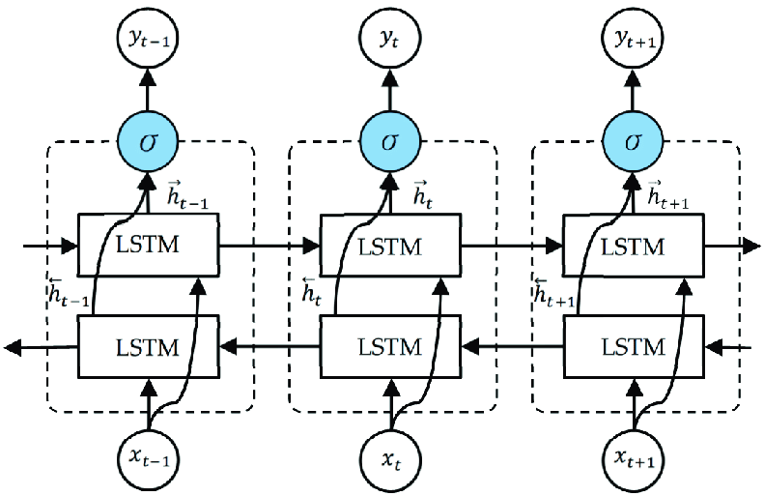
On the other hand, BiLSTM is a bidirectional LSTM approach, and it is more complicated than LSTM. BiLSTM contains five layers, input layer, embedding layer, BiLSTM layer, concatenation layer, and output layer (Zhang et al., 2020). Figure 3 demonstrates the architecture of the BiLSTM model.

Figure 3. Graphical representation of BiLSTM
In the first layer, the input layer, let D = d₁, d₂, d₃, …, d_{v} be the total number of dimensions the data input. Then, i₁, i₂, i₃, …, i_{n} be the total unique indices in each dimension. The data is now carried as a sequence of unique indices that allows the embedding layer and BiLSTM layer to compute (Hameed & Garcia-Zapirain, 2020). The input layer processes data into the machine and organizes it, preparing for later data processing and model running.
The embedding layer transformed the input into an embedding matrix with dimension n*d, where n depicts the number of indices in dimension d (Hameed & Garcia-Zapirain, 2020). The resulting embedding matrix X looks approximately like the following.
$$X= \left[\begin{matrix}\begin{matrix}\begin{matrix}x_{1,1} \\ x_{2,1} \\ x_{3,1}\end{matrix} & \begin{matrix}x_{1,2} \\ x_{2,2} \\ x_{3,2}\end{matrix}\end{matrix} & \begin{matrix}⋯ \\ ⋯ \\ ⋯\end{matrix} & \begin{matrix}x_{1,d} \\ x_{2,d} \\ x_{3,d}\end{matrix} \\ \begin{matrix}⋮ & ⋮\end{matrix} & ⋱ & ⋮ \\ \begin{matrix}\begin{matrix}x_{n−1, 1} \\ x_{n, 1}\end{matrix} & \begin{matrix}x_{n−1,2} \\ x_{n,2}\end{matrix}\end{matrix} & \begin{matrix}⋯ \\ ⋯\end{matrix} & \begin{matrix}x_{n−1,d} \\ x_{n,d}\end{matrix}\end{matrix}\right]$$
The BiLSTM layer processes the pre-embedded data into the BiLSTM model. In this situation, BiLSTM is used to predict the hidden state $H = (h_{1}, h_{2}, …, h_{n})$, which is concatenated from both forward to back and back to forward. The hidden state in this paper will be the dollar against the CNY exchange rate. At time t, for the input x_{t}, the hidden unit vector function $\vec{h}$ is calculated based on the previous hidden state ${\vec{h}}_{t−1}$. At the same time, a backward hidden function $\overset{⃖}{h}$ is calculated based on the future hidden state ${\overset{⃖}{h}}_{t+1}$.
In the concatenation layer, for each t, the hidden states at both directions $\vec{h}$ and $\overset{⃖}{h}$, are concatenated into a long vector (Chen et al., 2017). Mathematically, the hidden vector h is represented as follows:
$$h_{t}={{\vec{h}}_{t} ⨁ \overset{⃖}{h}}_{t}, h_{t}∈R^{2L}$$
Where $⨁$ represents the concatenation method and L means the size of each direction of LSTM. The output of BiLSTM can be summarized as a single strand $h_{t}=[{{\vec{h}}_{t}, \overset{⃖}{h}}_{t}]$.
Lastly, the final value after the concatenation layer is shown in the output layer.

2.3 Support vector regression
Support vector regression (SVR) is a regression model adopted from the basis of support vectors. In a nutshell, SVR divides the dataset into different classes, and the response variable’s prediction will be classified into one of those classes.
Considering a set of training dataset $\{\left(x_{1},y_{1}\right), …,(x_{l},y_{l})\}$ $⊂Χ×ℝ$, where $Χ$ is a matrix for the input patterns. We define an ε-SV regression as finding a function that for each predicted point, has at most ε deviation, to the actual point (Cortes & Vapnik, 1995). This means this regression will not accept any deviations larger than ε.
We begin by assuming the function we want to achieve is a linear one. For the linear function $f$:
$$f\left(x\right)=\left\langle ω\right.,\left.x\right\rangle +b, ω∈Χ, b∈ℝ$$
With $ω$ is a vector in $Χ$, and $\left\langle ω\right.,\left.x\right\rangle$ represent the dot product of two vectors. To keep the regression flat, we need a smaller $ω$. Therefore, we tried to minimize $\left\langle ω\right.,\left.ω\right\rangle = \frac{1}{2}{\left\|ω\right\|}^{2}$, in an optimization problem:
$$\text{minimize} \frac{1}{2}{\left\|ω\right\|}^{2}$$
$$\text{S.T.} \left\{\begin{aligned}y_{i}−\left\langle ω\right.,\left.x_{i}\right\rangle −b≤ε \\ \left\langle ω\right.,\left.x_{i}\right\rangle +b−y_{i}≤ε\end{aligned}\right.$$
This optimization problem will only exist is all of the points can lie between +ε and -ε. However, for some set of data, we cannot achieve that. Therefore, a slack variable, representing the difference between $x_{i}$ to +ε or -ε is implemented as $ξ_{i}\text{, }ξ_{i}^{∗}$ (Wu et al., 2004). Therefore, we arrive a new optimization, which minimizes the $\left\langle ω\right.,\left.ω\right\rangle$ as well as $ξ_{i}\text{, }ξ_{i}^{∗}$. The new equation will be:
$$\text{minimize} \frac{1}{2}{\left\|ω\right\|}^{2}+C\sum_{i=1}^{l}{{(ξ}_{i}\text{+}ξ_{i}^{∗})}$$
$$\text{S.T.} \left\{\begin{aligned}y_{i}−\left\langle ω\right.,\left.x_{i}\right\rangle −b≤ε+ξ_{i} \\ \left\langle ω\right.,\left.x_{i}\right\rangle +b−y_{i}≤ε+ξ_{i}^{∗} \\ ξ_{i}\text{, }ξ_{i}^{∗}≥0\end{aligned}\right.$$
where C is a constant that means the trade-off of flatness to the deviations it allows (Smola & Schölkopf, 2004). This equation is the final model proposed, effectively making valid predictions.

2.4 Extreme learning machine and Kernel extreme learning machine
Extreme learning machine (ELM) is another deep learning model we will compare with. This model was first introduced in 2006, aiming to improve the efficiency of the single-hidden-layer feedforward network (SLFNs) (Huang et al., 2006).
Overall, there are numerous benefits of ELM over other SLFN networks. First, the speed of ELM is extremely fast. It takes only seconds or faster than seconds to finish the model’s learning phase (Huang et al., 2006). For complicated models, the ELM learning machine only spends 1.6 minutes on running, but similar algorithms, such as SVR, takes 12 hours (Huang et al., 2006). This makes the model run more efficient than before. Second, the model is more effective than other SLFN models.
Secondly, the ELM model's simplicity reduces multiple problems in other traditional gradient-based learning machines, such as overfitting and improper learning rate (Huang et al., 2006). The simple and straightforward ELM algorithm minimized these problems overall.
For N arbitrary distinct training samples of inputs (x_{i}, t_{i}), which x_{i} represents ${[x_{i1}, x_{i2}, …,x_{in}]}^{T} ∈ R^{n}$ and t_{i} represents ${[t_{i1}, t_{i2}, …,t_{im}]}^{T}∈R^{m}$. Therefore, the training sample $\left(x_{i},t_{i}\right)∈R^{n}×R^{m}, (i=1, 2, 3,…,N)$, the output of SLFN for $\tilde{N}$ hidden nodes can be represented as:
$$o_{j}=\sum_{i=1}^{\tilde{N}}{β_{i}f_{i}(x_{j})}=\sum_{i=1}^{\tilde{N}}{β_{i}f(a_{i}∙x_{j}+b_{i})}, j=1, 2,…,N$$
Where $o_{j}$ is the output in SLFN, for input $x_{i}, i=1, 2,…,N$. $a_{i}$ and $b_{i}$ are the learning parameters for j^{th} hidden node, and there are $N$ hidden nodes in total. $β_{i}={[β_{i1},β_{i2},…,β_{im}]}^{T}$ is a linking parameter connecting between the j^{th} hidden node to the output $o_{j}$ (Ding et al., 2014). $f(a_{i}∙x_{j}+b_{i})$ is the activation function for the SLFN (Ding et al., 2014).
The equation above can be represented concisely as:
$$Hβ=O$$
And H is the output matrix for the hidden layer, β is the linking matrix between hidden layer and outputs, and O is the output matrix for the SLFN (Ding et al., 2015). They can be represented mathematically as:
$$H={\left[\begin{matrix}f(a_{1}∙x_{1}+b_{1}) & ⋯ & f(a_{i}∙x_{j}+b_{i}) \\ ⋮ & ⋱ & ⋮ \\ f(a_{1}∙x_{N}+b_{1}) & ⋯ & f(a_{i}∙x_{j}+b_{i})\end{matrix}\right]}_{N×\tilde{N}},$$
$$β={\left[\begin{matrix}β_{1}^{T} \\ ⋮ \\ β_{\tilde{N}}^{T}\end{matrix}\right]}_{\tilde{N}×m}, O={\left[\begin{matrix}O_{1}^{T} \\ ⋮ \\ O_{N}^{T}\end{matrix}\right]}_{N×m}$$
For minimizing $\left\|O−T\right\|$ in ELM model, $a_{i}$ and $b_{i}$ are needed to be assigned randomly without considering the input data. Therefore, this model now became a linear one, using the Moore-Penrose (MP) generalization of H, denoted as $H^{†}$ (Chen et al., 2016).
Therefore, the output weight $β$ will be produced by the algorithm below after transformation, which finishes the ELM model:
$$β=H^{†}Τ$$
Kernel extreme learning machine (KELM) is a Kernel approach to ELM. Multiple variations of KELM are used in previous research, such as multiple KELM (Liu et al., 2015), hybrid KELM (Lv et al., 2020). Variations of kernels also exist, such as the radial basis function (RBF) kernel (Iosifidis et al., 2015), exponential radial basis function (ERBF) kernel (Madheswaran & Dhas, 2015). In this research, the RBF kernel is used. This kernel is added to the ELM model making it more accurate in testing data. It is a popular kernel used in multiple areas. The RBF kernel can be defined as:
$$K_{RBF}\left(\text{x}, \text{x'}\right)=exp⁡[−γ{\left\|\text{x-x'}\right\|}^{2}]$$
where $γ$ is the parameter that sets the spread of the kernel (Ding et al., 2021). By using such method, a more accurate prediction might be achieved.
- Empirical Study

3.1 Data collection
29 variables ranging from various fields are selected, including: (1)Macroeconomic variables: Federal exchange reserve (FER), export value (EX), import value (IM), China money supply (CM2), China consumer price index (CCPI), industrial value added (IVA), Producer Price Index (PPI), purchasing managers' index (PMI), America consumer price index(ACPI), dollar index (DXY), America money supply (AM2), Global economic policy uncertainty (GEPU), China economic policy uncertainty (CEPU), America economic policy uncertainty (AEPU), America Economic Policy Uncertainty: News Index (AEPU-NI). (2) Financial assets: West Texas Intermediate (WTI), future closing price of gold (FCPG), Dow Jones industrial average (DJIA), NASDAQ Composite Index (NASDAQ), The S&P 500 index (S&P), S&P 500 Volatility Index (VIX), Shenzhen composite index (SZCOMP), Shanghai composite index (SHCOMP). (3) Sentimental index: University of Michigan consumer sentiment index (UMCSI), average searching number in Google Trends(GT), average searching number in Baidu index(BI). (4) Other composite indicators: China composite leading indicator (CLI_China), global composite leading indicator (CLI_Global), America composite leading indicator (CLI_US).
Table 1: Selected variables within four categories
Category | Detailed variables
Macroeconomic variables | FER, EX, IM, CM2, CCPI, IVA, PPI, PMI, ACPI, DXY, AM2, GEPU, CEPU, AEPU, AEPU-NI (15)
Financial assets | WTI, FCPG, DJIA, NASDAQ, S&P, VIX, SZCOMP, SHCOMP (8)
Sentimental index | UMCSI, GT, BI(3)
Other Composite indicators | CLI_China, CLI_Global, CLI_US(3)
In total, fifteen macroeconomic variables, eight financial asset variables, three sentimental variables, and three other composite indicators are chosen. The monthly data of GT and BI are obtained from google trends (https://trends.google.com/trends/) and the Baidu index (https://index.baidu.com/v2/index.html), respectively. UMCSI is obtained from Fred economic data (https://fred.stlouisfed.org/series/UMCSENT), CLI_China, CLI_Global, and CLI_US are obtained from OEDC (https://data.oecd.org/leadind/composite-leading-indicator-cli.htm), other variables are obtained from the Wind Database (http://www.wind.com.cn/).
The data were selected from January 2011 to June 2022, separated into an in-sample subset and an out-of-sample subset. The in-sample subset contains the former 80% of the data, while the out-of-sample subset contains the rest of the 20%. Thus, 1) the in-sample subset is used for model training with the data from January 2011 to February 2020. 2) the out-sample subset is used for testing with the data from March 2020 to June 2022.
Five seed words are selected for GT and BI, which are: RMB to US dollar exchange rate, RMB exchange rate, RMB to US dollar, Dollar RMB exchange rate, and Dollar renminbi exchange. In this cast, GT is used to represent public opinions in the US, while BI is used to represent public opinions in China. Moreover, the average monthly searching volume is used to represent the overall public opinions toward the exchange rate in different periods.
A logarithmic transformation is applied to the variables that contain data greater than 100, which are: FER, EX, CM2, AM2, FCPG, DJIA, NASDAQ, S&P, SZCOMP, SHCOMP, BI.
The statistical properties of the exchange rate and selected variables are represented in Table 2. The data distributions of CLI_China and PPI are relatively asymmetric since the absolute skew are the greatest, while M2 and WTI tend to be symmetric distributions. For kurtosis, since the value of CEPU is greater than 3, the data distribution is mesokurtic, while the other variables are platykurtic distributed.
Table 2. Statistical properties of variables
Variables | mean | Standard deviation | skewness | kurtosis | Jarque-bera | P-value | Observation
FER | 10.41 | 0.09 | 0.28 | 2.59 | 2.22 | 0.00 | 109
EX | 7.52 | 0.16 | 0.26 | 1.84 | 7.38 | 0.03 | 109
IM | 7.34 | 0.13 | 0.31 | 1.79 | 8.45 | 0.14 | 109
M2 | 14.07 | 0.29 | 0.02 | 1.91 | 5.36 | 0.00 | 109
CPI | 2.55 | 1.29 | 0.46 | 1.86 | 9.82 | 0.32 | 109
CPI_US | 1.80 | 0.89 | 0.48 | 1.88 | 9.94 | 0.00 | 109
IVA | 7.93 | 3.61 | 0.17 | 1.84 | 6.62 | 0.00 | 109
PPI | 0.39 | 4.02 | 0.76 | 2.58 | 11.29 | 0.00 | 109
PMI | 50.67 | 0.93 | 0.42 | 1.90 | 8.68 | 0.82 | 109
DXY | 89.17 | 8.42 | -0.27 | 2.55 | 2.25 | 0.00 | 109
WTI | 71.55 | 22.82 | 0.01 | 2.46 | 1.28 | 0.00 | 109
COMEX | 7.21 | 0.13 | 0.40 | 2.02 | 7.21 | 0.46 | 109
DJIA | 9.78 | 0.27 | -0.16 | 1.80 | 6.94 | 0.00 | 109
NASDAQ | 8.46 | 0.37 | -0.19 | 1.83 | 6.82 | 0.00 | 109
AM2 | 9.39 | 0.15 | 0.04 | 2.00 | 4.61 | 0.00 | 109
S&P | 7.59 | 0.28 | -0.20 | 1.78 | 7.43 | 0.00 | 109
VIX | 16.20 | 4.82 | 0.35 | 1.97 | 7.04 | 0.21 | 109
UMCSI | 87.13 | 10.83 | -0.03 | 2.00 | 4.56 | 0.00 | 109
SZCOMP | 9.19 | 0.17 | 0.47 | 1.98 | 8.77 | 0.53 | 109
SHCOMP | 7.91 | 0.19 | 0.12 | 2.74 | 0.57 | 0.00 | 109
GEPU | 5.03 | 0.31 | 0.33 | 2.30 | 4.31 | 0.00 | 109
CEPU | 5.47 | 0.78 | 0.63 | 3.62 | 9.20 | 0.00 | 109
AEPU | 4.81 | 0.26 | 0.49 | 1.81 | 10.70 | 0.04 | 109
AEPU-NI | 4.92 | 0.31 | 0.29 | 1.91 | 6.98 | 0.00 | 109
CLI_China | 99.92 | 0.95 | 0.80 | 2.84 | 11.87 | 0.00 | 109
CLI_US | 100.00 | 0.61 | 0.53 | 2.00 | 9.69 | 0.00 | 109
CLI_Global | 100.07 | 0.58 | 0.37 | 1.60 | 11.43 | 0.00 | 109
BI | 8.33 | 0.64 | 0.21 | 2.23 | 3.45 | 0.00 | 109
GT | 42.07 | 11.10 | 0.44 | 2.32 | 5.67 | 0.00 | 109

LASSO is used to filter variables. Former 80% of data (from January 2011 to February 2020) are used to select variables. As a penalty is added to the residual sum of square, some variables’ coefficients shrink to zero, which can be illustrated in Figure 4. Eventually, six variables are filtered: FER, DXY, S&P, GEPU, CEPU, and BI.
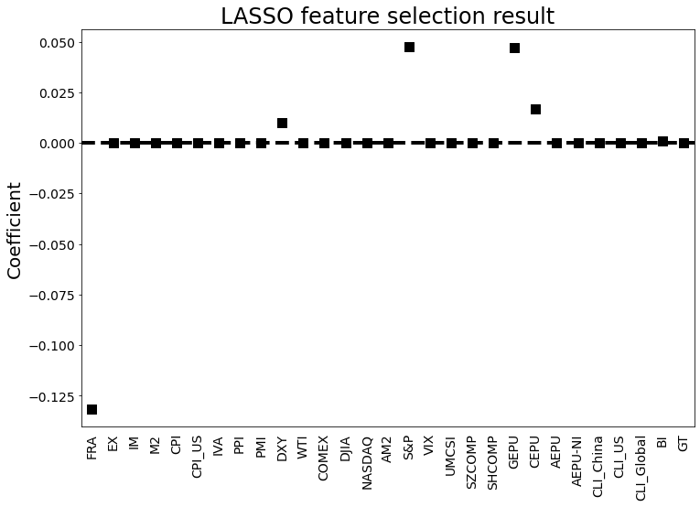
Figure 4. The coefficients of different variables for LASSO

3.2 Evaluation Criteria
Five machine learning approaches are used to make comparisons, including SVR, ELM, LSTM, BiLSTM, and KELM to find a model with strong predictive power.
Meanwhile, three methods are used to evaluate the level of forecasting accuracy, including MAE, RMSE. Here are the following formulas:
MAE=$\frac{\sum_{t=1}^{n}{\left|\hat{Y_{t}}−Y_{t}\right|}}{n}$
RMSE=$\sqrt{\frac{1}{n}\sum_{t=1}^{n}{{(Y_{t}−\hat{Y_{t}})}^{2}}}$
where $Y_{t}$ and $\hat{Y_{t}}$ stand for the actual value and forecast value at time t respectively, while n represents the number of observations. For MAE and RMSE, the smaller calculated values represent smaller errors, which means there are less deviation between the actual value and the forecast value.
- Performance comparison

4.1 Forecasting Performance
This section discusses the forecasting accuracy of five machine learning approaches and LASSO-combining approaches. 1 step forecasting, 3 step forecasting, and 6 step forecasting on each of the models to are performed. Results from adapting 29 variables and LASSO selection models are compared.
Table 3: Evaluated performance of 1-step forecasting
 | MAE | RMSE
SVR | 0.264 | 0.322
ELM | 0.180 | 0.233
LSTM | 0.337 | 0.388
BiLSTM | 0.102 | 0.132
KELM | 0.252 | 0.277
LASSO-SVR | 0.190 | 0.227
LASSO-ELM | 0.164 | 0.208
LASSO-LSTM | 0.107 | 0.151
LASSO-BiLSTM | 0.051 | 0.072
LASSO-KELM | 0.095 | 0.125
Table 3 illustrates the forecasting error on 1-step forecasting. The table shows that LASSO enhances the forecasting accuracy effectively since the calculated value has greatly shrunk for LASSO selection models than pure neural network models. Moreover, the result illustrates that LASSO-BiLSTM has the smallest error under MAE and RMSE criteria, which are 0.051 and 0.072. This demonstrates that LASSO-BiLSTM would be the best model.
We continue looking at the results on 3-steps forecasting and 6-steps forecasting. Table 4 demonstrates the model performance errors in 3-steps forecasting, where table 5 shows the errors for 6-steps forecasting.
Table 4: Evaluated performance of 3-steps forecasting
 | MAE | RMSE
SVR | 0.278 | 0.418
ELM | 0.265 | 0.321
LSTM | 0.334 | 0.401
BiLSTM | 0.186 | 0.245
KELM | 0.240 | 0.260
LASSO-SVR | 0.221 | 0.284
LASSO-ELM | 0.183 | 0.218
LASSO-LSTM | 0.147 | 0.195
LASSO-BiLSTM | 0.127 | 0.147
LASSO-KELM | 0.146 | 0.169
Table 5: Evaluated performance of 6-steps forecasting
 | MAE | RMSE
SVR | 0.465 | 0.671
ELM | 0.252 | 0.283
LSTM | 0.325 | 0.356
BiLSTM | 0.333 | 0.363
KELM | 0.275 | 0.297
LASSO-SVR | 0.211 | 0.293
LASSO-ELM | 0.212 | 0.248
LASSO-LSTM | 0.237 | 0.287
LASSO-BiLSTM | 0.189 | 0.204
LASSO-KELM | 0.226 | 0.236
As shown in table 4 and 5, in both 3-steps forecasting and 6-steps forecasting, LASSO-BiLSTM always has the lowest error. Moreover, the error for LASSO selection models is a much lower than pure neural network model. Therefore, LASSO selection is effective at exchange rate prediction. The multi-step forecasting accurately verified the results from 1-step forecasting.
Figure 5, as shown below, demonstrates the real exchange rate and the predicted exchange rate in 1-step forecasting for all models. Graphically seen, LASSO-BiLSTM has the most accurate prediction.
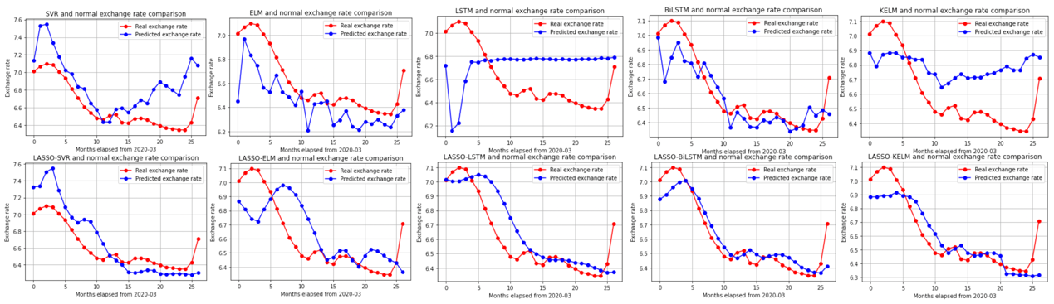
Figure 5. Visualization of forecasting results
The proposed model can be used to forecast the exchange rate effectively, and outperform the benchmarks. Several important conclusions can be drawn from the performance comparison above: (1) our proposed model can outperform the benchmarks in forecasting exchange rate with MAE and RMSE; (2) the LASSO-based models generally outperforms the single models since the LASSO method of feature selection does reduce overfitting and thus gives a more promising result; (3) The BiLSTM-based model is generally performs better than the other models, that is BiLSTM is more suitable to deal with the high volatility and nonlinear patterns in the time series of exchange rates. (4) exchange rate fluctuations are influenced by a variety of factors, and compared with the previous study, it is the first time that the market-based variables and macroeconomic variables have been selected to predict the exchange rate of USD/CNY. The proposed model contains more information to simulate the fluctuations of exchange rate and get more accurate predictions.
Furthermore, the 29 variables have been selected from various dimensions to predict the exchange rate of USD/CNY, our result gives new implications of what variables are significantly related to the exchange rate forecast. More specifically, 6 variables have the highest relevance with the forecast, which are: FER, DXY, S&P, GEPU, CEPU, and BI.
Foreign exchange reserves (FER) are foreign assets held by the central bank, which may be in the form of foreign currency, bonds, treasury bills, and other government securities. The explicit relationship between the exchange rate and foreign exchange reserves is that as CNY depreciated, a trade surplus would occur and thus the foreign exchange reserve would be accumulated. However, in the long run, the correlation between China’s foreign exchange reserves and the exchange rate has been found positive (Narayan & Smyth, 2006).
The U.S. Dollar Index (DXY) is used to evaluate the value of the dollar against a basket of six foreign currencies, which are the Euro, Swiss Franc, Japanese Yen, Canadian Dollar, British Pound, and Swedish Krona. An increase in DXY means that the Dollar is gaining strength compared to the currencies of other countries, and thus the market sentiment would be influenced. Then, the transaction in the international market would further affect the exchange rate of the dollar against the CNY. Even though the interactions between DXY and the exchange rate are relatively intermediate, DXY still has a relatively significant effect on the response variable as this research shows. We induce that DXY incorporates the international market’s situations and sentiments greatly, and thus enhances forecasting accuracy.
S&P 500 is a stock market index that reflects the stock performance of 500 leading companies in the U.S. The overall trend of the S&P 500 reflects investors’ sentiments toward the U.S. stock market and affects investors’ decisions on fund purchases since the index can be used as a benchmark. Moreover, Lilley and Rinaldi (2018) have first illustrated that S&P 500 and exchange rate began to move synchronously since the financial crisis, which is tightly related to proxies’ risk preference. Based on this research, Lilley et al. (2020) have further discovered that the U.S. dollar is likely to depreciate when risk appetite is high. Since BiLSTM is highly sensitive to market sentiment, the forecasting accuracy would be relatively ideal as S&P 500 is adopted.
The measurement of economic policy uncertainties (EPU) incorporates three components: quantification of policy-related economic uncertainty as shown by the newspaper, index reported by the Congressional Budget Office (CBO), and the uncertainty index drawn from Federal Reserve Bank of Philadelphia's Survey of Professional Forecasters (Economic Policy Uncertainty Index, 2012). Since the newspaper-based measurement is adopted, the capture of uncertainty would incorporate textual sentiment. This shows a high consistency with BiLSTM’s characteristic, which adopts a bidirectional prediction of texts and shows high sensitivity to emotion. Other sentiment analyses have also been done based on BiLSTM (Xu et al., 2019). Moreover, since the sample data of exchange rates are selected from a long-term scale, they would be more volatile. Liming et al. (2019) illustrate that as the volatility of exchange rates increases, the positive shock of EPU would also increase. This positive feedback loop illustrates the tight positive relationship between EPU and the exchange rate under uncertainty. Thus, if two indexes show consistency, the forecasting result brought by BiLSTM would also be more accurate.
Baidu Index (BI) illustrates the search volume of 5 keywords, which are: RMB to US dollar exchange rate, RMB exchange rate, RMB to US dollar, Dollar RMB exchange rate, and Dollar renminbi exchange. High search volume may reveal the public’s attention to the exchange rate and foreign exchange market over a period of time, and thus reflect the fluctuation of market sentiments. Lin et al. (2022) have found that BI is effective for the exchange rate forecast by using the BiLSTM model, which is consistent with this research’s result.

4.2 Diebold-Mariano Test
To further verify the statistical superiority of the proposed approach, the Diebold-Mariano (DM) test is utilized (Diebold and Mariano, 2002). The DM test is performed by checking the loss differential expectation score. Where the null hypothesis ($H_{0}$) is that the two forecasts have equal predicting accuracy. The null hypothesis can only be rejected if the significance level is lower than 10%. The loss differential is calculated according to the root mean squared error (RMSE), which is one of the errors we have tested in the model.
Table 6: Diebold-Mariano test on results performance
 | SVR | ELM | LSTM | BiLSTM | KELM | LASSO-SVR | LASSO-ELM | LASSO-LSTM | LASSO-KELM
LASSO-BiLSTM | -3.921* | -3.490* | -3.807* | -2.108** | -5.394* | -4.291* | -4.120* | -2.949* | -3.019*
SVR |  | -0.732 | -1.264 | 3.479* | 1.590 | 1.795*** | 2.122** | 2.905* | 3.474*
ELM |  |  | -0.306 | 3.226* | 1.322 | 2.444** | 2.432** | 2.746** | 3.154*
LSTM |  |  |  | 3.997* | 1.559 | 2.723** | 2.919* | 3.152* | 3.600*
BiLSTM |  |  |  |  | -4.059* | -3.185* | -2.776* | -0.618 | 0.288
KELM |  |  |  |  |  | 1.231 | 1.815** | 3.248* | 4.044*
LASSO-SVR |  |  |  |  |  |  | 1.402 | 2.755** | 4.067*
LASSO-ELM |  |  |  |  |  |  |  | 2.931* | 3.454*
LASSO-LSTM |  |  |  |  |  |  |  |  | 1.117
* 1% Significance Level
** 5% Significance Level
*** 10% Significance Level
All of the DM statistics for LASSO-BiLSTM are negative and p values are smaller than 10%, the null hypothesis is rejected. It is revealed that the LASSO-BiLSTM approach is far superior to the other benchmarks under 99% confidence level.
- Conclusion
In this paper, the novel LASSO-BiLSTM-based ensemble learning method is proposed to predict the USD/CNY exchange rate. The framework of the proposed approach includes three steps. Firstly, 29 related variables from four different categories are selected. Secondly, LASSO feature selecting approach is used to choose six variables with the greatest relevance. Lastly, five deep learning methods (SVR, ELM, LSTM, KELM, BiLSTM) that employ 29 related variables and LASSO-combining models (LASSO-SVR, LASSO-ELM, LASSO-LSTM, LASSO-KELM) are adopted to forecast the exchange rate of USD/CNY, indicating that LASSO-BiLSTM has the best performance and LASSO plays an important role in forecasting accurately. Future studies can apply LASSO-BiLSTM-based ensemble learning approach in other commodity markets or financial markets.

- 最后一段
- 表格格式调整
- 为什么p value有负的
- 改变量名称！！一致！！
- Lasso 用词

参考文献：
Aslan, M. F., Unlersen, M. F., Sabanci, K., & Durdu, A. (2021). CNN-based transfer learning–BiLSTM network: A novel approach for COVID-19 infection detection. Applied Soft Computing, 98, 106912.
Baffour, A. A., Feng, J., & Taylor, E. K. (2019). A hybrid artificial neural network-GJR modeling approach to forecasting currency exchange rate volatility. Neurocomputing, 365, 285-301.
Bulut, L. (2018). Google Trends and the forecasting performance of exchange rate models. Journal of Forecasting, 37(3), 303-315.
Cashin, P., Céspedes, L. F., & Sahay, R. (2004). Commodity currencies and the real exchange rate. Journal of Development Economics, 75(1), 239-268.
Chen, H. L., Wang, G., Ma, C., Cai, Z. N., Liu, W. B., & Wang, S. J. (2016). An efficient hybrid kernel extreme learning machine approach for early diagnosis of Parkinson׳ s disease. Neurocomputing, 184, 131-144.
Chen, L., Du, Z., & Hu, Z. (2019). Impact of economic policy uncertainty on exchange rate volatility of China. Finance Research Letters. https://doi.org/10.1016/j.frl.2019.08.014
Chen, T., Xu, R., He, Y., & Wang, X. (2017). Improving sentiment analysis via sentence type classification using BiLSTM-CRF and CNN. Expert Systems with Applications, 72, 221-230.
Cortes, C., & Vapnik, V. (1995). Support-vector networks. Machine learning, 20(3), 273-297.
Datta, R. K., Sajid, S. W., Moon, M. H., & Abedin, M. Z. (2021). Foreign Currency Exchange Rate Prediction Using Bidirectional Long Short Term Memory. Studies in Computational Intelligence, 213–227. https://doi.org/10.1007/978-3-030-73057-4_17
Ding, S., Xu, X., & Nie, R. (2014). Extreme learning machine and its applications. Neural Computing and Applications, 25(3), 549-556.
Ding, S., Zhao, H., Zhang, Y., Xu, X., & Nie, R. (2015). Extreme learning machine: algorithm, theory and applications. Artificial Intelligence Review, 44(1), 103-115.
Ding, X., Liu, J., Yang, F., & Cao, J. (2021). Random radial basis function kernel-based support vector machine. Journal of the Franklin Institute, 358(18), 10121-10140.
Economic Policy Uncertainty Index. (2012). Policyuncertainty.com. https://www.policyuncertainty.com/
Hameed, Z., & Garcia-Zapirain, B. (2020). Sentiment classification using a single-layered BiLSTM model. IEEE Access, 8, 73992-74001.
Henríquez, J., & Kristjanpoller, W. (2019). A combined Independent Component Analysis–Neural Network model for forecasting exchange rate variation. Applied Soft Computing, 83, 105654.
Hochreiter, S., & Schmidhuber, J. (1997). Long short-term memory. Neural computation, 9(8), 1735-1780.
Huang, G. B., Zhu, Q. Y., & Siew, C. K. (2006). Extreme learning machine: theory and applications. Neurocomputing, 70(1-3), 489-501.
Iosifidis, A., Tefas, A., & Pitas, I. (2015). On the kernel extreme learning machine classifier. Pattern Recognition Letters, 54, 11-17.
Islam, M. S., & Hossain, E. (2020). Foreign exchange currency rate prediction using a GRU-LSTM hybrid network. Soft Computing Letters, 100009.
Jain, A., & Biswal, P. C. (2016). Dynamic linkages among oil price, gold price, exchange rate, and the stock market in India. Resources Policy, 49, 179-185.
Kim, Y., & Park, C. (2020). Are exchange rates disconnected from macroeconomic variables? Evidence from the factor approach. Empirical Economics, 58(4), 1713-1747.
Lilley, A., Maggiori, M., Neiman, B., & Schreger, J. (2020). Exchange Rate Reconnect. The Review of Economics and Statistics, 1–28. https://doi.org/10.1162/rest_a_00978
Lilley, A., & Rinaldi, G. (2018, October 8). Currency Betas and Interest Rate Spreads. Papers.ssrn.com. https://ssrn.com/abstract=3262313
Lin, Y., Wang, R., Gong, X., & Jia, G. (2022). Cross-correlation and forecast impact of public attention on USD/CNY exchange rate: Evidence from Baidu Index. Physica A: Statistical Mechanics and Its Applications, 127686. https://doi.org/10.1016/j.physa.2022.127686
Liu, X., Wang, L., Huang, G. B., Zhang, J., & Yin, J. (2015). Multiple kernel extreme learning machine. Neurocomputing, 149, 253-264.
Lu, X., Li, J., Zhou, Y., & Qian, Y. (2017). Cross-correlations between RMB exchange rate and international commodity markets. Physica A: Statistical Mechanics and its Applications, 486, 168-182.
Lv, L., Wang, W., Zhang, Z., & Liu, X. (2020). A novel intrusion detection system based on an optimal hybrid kernel extreme learning machine. Knowledge-based systems, 195, 105648.
Madheswaran, M., & Dhas, D. A. S. (2015). Classification of brain MRI images using support vector machine with various Kernels. Biomedical Research, 26(3), 505-513.
Narayan, P. K., & Smyth, R. (2006). The dynamic relationship between real exchange rates, real interest rates and foreign exchange reserves: empirical evidence from China. Applied Financial Economics, 16(9), 639–651. https://doi.org/10.1080/09603100500401278
Sherstinsky, A. (2020). Fundamentals of recurrent neural network (RNN) and long short-term memory (LSTM) network. Physica D: Nonlinear Phenomena, 404, 132306.
Singhal, S., Choudhary, S., & Biswal, P. C. (2019). Return and volatility linkages among International crude oil price, gold price, exchange rate and stock markets: Evidence from Mexico. Resources Policy, 60, 255-261.
Smola, A. J., & Schölkopf, B. (2004). A tutorial on support vector regression. Statistics and computing, 14(3), 199-222.
Sujit, K. S., & Kumar, B. R. (2011). Study on the dynamic relationship among gold price, oil price, exchange rate and stock market returns. International journal of applied business and economic research, 9(2), 145-165.
Tibshirani, R. (1996). Regression shrinkage and selection via the lasso. Journal of the Royal Statistical Society: Series B (Methodological), 58(1), 267-288.
Tibshirani, R. (1997). The lasso method for variable selection in the Cox model. Statistics in medicine, 16(4), 385-395.
Wei, Y., Sun, S., Lai, K. K., & Abbas, G. (2018). A KELM-Based Ensemble Learning Approach for Exchange Rate Forecasting. Journal of Systems Science and Information, 6(4), 289-301.
Wu, C. H., Ho, J. M., & Lee, D. T. (2004). Travel-time prediction with support vector regression. IEEE transactions on intelligent transportation systems, 5(4), 276-281.
Xu, G., Meng, Y., Qiu, X., Yu, Z., & Wu, X. (2019). Sentiment Analysis of Comment Texts Based on BiLSTM. IEEE Access, 7, 51522–51532. https://doi.org/10.1109/access.2019.2909919
Zhang, Y., Wang, J., & Zhang, X. (2018, June). Ynu-hpcc at semeval-2018 task 1: Bilstm with attention based sentiment analysis for affect in tweets. In Proceedings of The 12th International Workshop on Semantic Evaluation (pp. 273-278).

Acknowledgement
- 论文的选题来源、研究背景
The news from The Economists provides us a window to learn more thoroughly what is happening worldwide. We are usually amazed by the critical analysis: double-sworded effects brought by the increasing interest rate, possible approaches to get through the winter without wrecking Europe’s electricity market, and the precise correlation between an increase in gas prices and the drop in consumption. For this time, not only do we want to perceive information from professional researchers, but we also want to take a further step, trying to be an analyst by raising our own methodology. Inspired by our instructor, the foreign exchange rate becomes our research object.

- 每一个队员在论文撰写中承担的工作以及贡献
In our team, Siyuan Liu is responsible for providing overall idea, constructing 6 models, writing the methodology part of the essay, and finding initial variables. Qiqian Huang is responsible for providing the overall idea, providing economical interpretations for the result, writing introduction and literature review.

- 指导老师与学生的关系，在论文写作过程中所起的作用，及指导是否有偿
We would like to thank Yunjie Wei for providing many academic guidance and advices for our work. Her guidance is unpaid, and her effort and patience sincerely affecting us. Only because of her, we made this work possible.

- 团队成员和指导老师的简历
Team member
Siyuan Liu and Qiqian Huang are two High School grade 11 students from Beijing 101 High School International Department.

Adviser: Yunjie Wei
April 2022 to Now: Associate Professor, Academy of Mathematics and Systems Science, Chinese Academy of Sciences
July 2017-April 2022: Assistant Professor, Academy of Mathematics and Systems Science, Chinese Academy of Sciences
2018.08.02-2018.10.01: Postdoctoral Fellow, City University of Hong Kong，Department of Information Systems (Research Fellow)
2019.07.02-2019.08.30: Postdoctoral Fellow, City University of Hong Kong，Department of Economics and Finance (Research Fellow)
2015.09-2018.02: City University of Hong Kong，College of Business, Ph.D.
2012.09-2017.06: Academy of Mathematics and Systems Science, University of Chinese Academy of Sciences, Ph.D.
2008.09-2012.06: School of Economy & Trade, Hunan University

Corresponding author’s email: weiyunjie@amss.ac.cn (Yunjie Wei), Postal Address: Academy of Mathematics and Systems Science, Chinese Academy of Sciences, Zhongguancun East Road, # 55, Haidian District, Beijing, PR China, Tel: +86 10 82541655 Acknowledgements: This research work was partly supported by the National Natural Science Foundation of China under Grants No. 72171223, No. 71801213 and No. 71988101

